LAB 9-2 Polymorphism

Working in folder “week10”.

1. Create a class Human following the example.

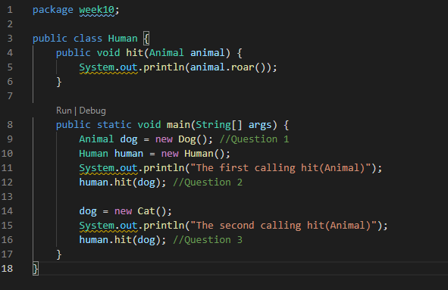

1. Create Animal ,Cat and Dog.



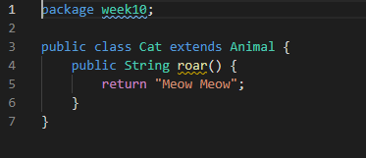

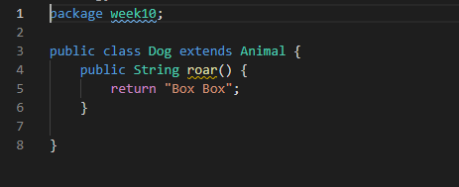

1. Compile and run the program.

Answer the question

* 1. At the //Question 1 of the *Human* class, *dog* is *Animal* type, Why we can assign the *Dog* object to *dog* ?
* Why we assign the Dog object to Dog. Because compiler Human object use explicit casting. However, explicit casting must be use to confirm your intention to the compiler with (subclassName) cast notation. It is because Dog object to be casting instance of the subclass.
  1. At line //Question 2 of Human class, there is the same statement,”human.hit(dog)”. Do they return the same result in the console ? Why?

Yes, because it displays the return result as dog return method.

* 1. Create a new *Fish* class which roars “…”. Then update the main method of the Person class so that *person* can hit *Fish*.